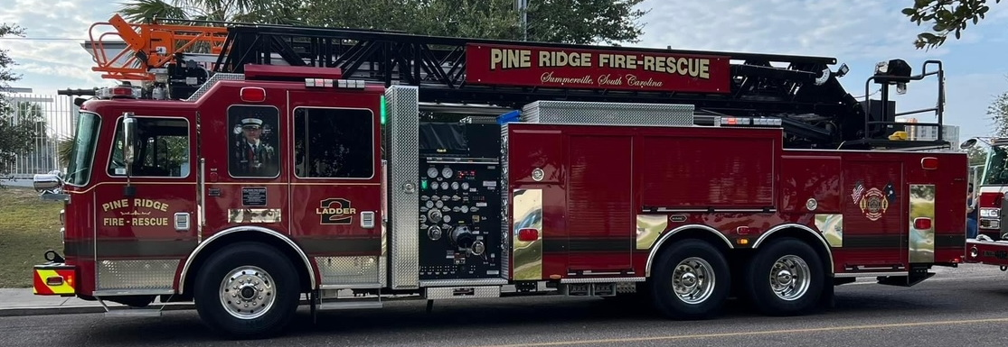

PINERIDGE FIRE DEPARTMENT
IS HIRING

ENGINEER – FULL TIME

Minimum qualifications include IFSAC FF2 Certification; IS 300; Current CPR/First Aid (EMR preferred); Auto Extrication; Pump Ops 1 and 2; Incident Safety Officer; Aerial Operations.

Starting rate for this position is $15.30/hour or $44,676 per year, base wages.
Benefits include Employee Health Insurance, SC PORS, and Vacation/PTO.

For more information visit
https://www.pineridgefd.org/membership-opportunities

Pine Ridge Fire Department is an equal opportunity employer.

